**PRESENCE in the Baviaanskloof Research Summary**

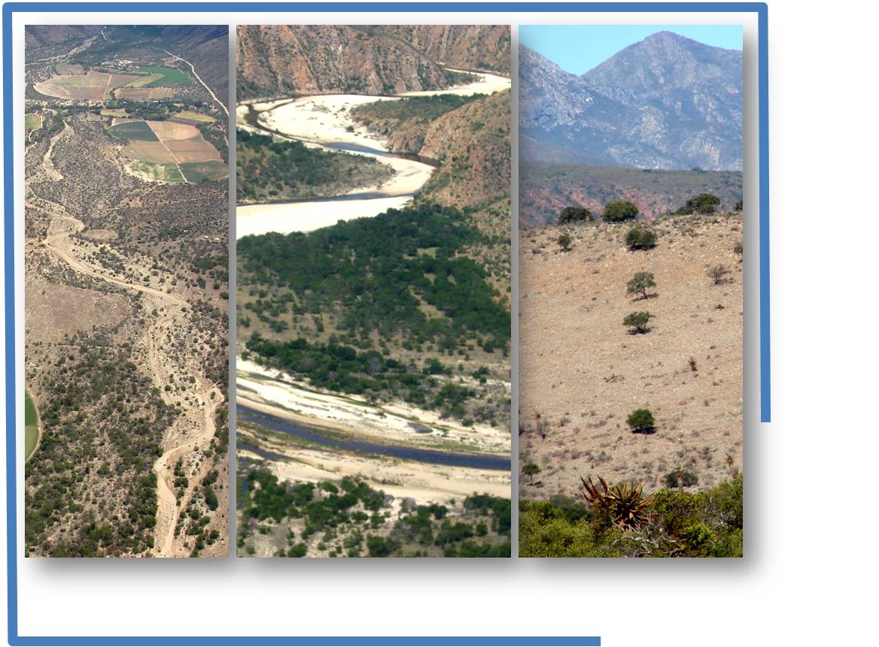

**Student Theses Summaries**

**Baviaanskloof Mega Reserve**

Photos: Japie Buckle

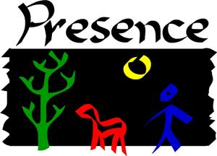



**Brief**

**This summary document is meant to provide a ‘quick glance’ at the research conducted over the last four years by students within the PRESENCE Network. It is categorized into broad themes adopted as a framework to guide the process, the Transdisciplinary Assessment and Implementation Framework (TAIF). For full reports, please contact the PRESENCE Learning Village at: +27(0) 42 283 0242. Email Odi:** [**odi@earthcollective.net**](mailto:odi@earthcollective.net)**, Julia:** [**julia@earthcollective.net**](mailto:julia@earthcollective.net)

# This summary is presented on the basis of the framework below. The idea was to present this as a sequential theme based *‘narrative’*.

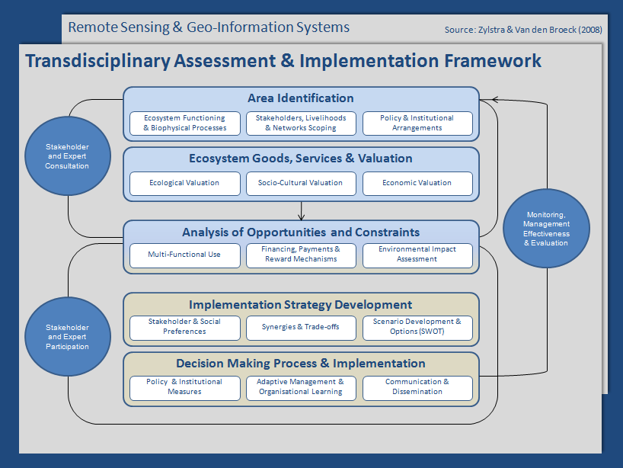

Figure : The conceptual space within which PRESENCE activities occur

# Theme 1: Area identification

# *Ecosystem functioning and Biophysical processes*

**Janeke Spekreijse (2009): Soil characteristics of the ten homogeneous vegetation types of the Great Fish River Reserve, with investigation of the optimum growth factors for *Portulacaria afra*.**

This thesis investigated the soil properties associated with vegetation types in the Great Fish River, including those related to *Portulacaria afra*, commonly known as *spekboom.* The rationale was that understanding those factors influencing floristic composition and change, is critical for devising management and restoration strategies for the thicket biome. The hypothesis advanced here was that high *P. afra* density will results in high carbon stocks. However, the results showed that it is the combination of all trees that increases the carbon storage content, as opposed to *P. afra* alone.

It has been argued however, that *P. afra* is a significant species within the semi arid thicket. This species, having a canopy dominance, provide a micro climate for other vegetation. From these, one can deduce that by providing an environment that allow other vegetation to flourish, *P. afra* induce an environment within which high carbon content in the soil result, from a combination of the *P. afra* itself, with other vegetation types.

**Jose David Diaz (2009): Technical Report of the Restoration of a section of the Witteklip Pilot Project for Rehabilitation of the Kouga River**

The main objective of this thesis was to describe the results from the activities oriented towards repairing the functionality of a section of the Witteklip River and to evaluate the possibilities of using fire as a method for the disposal of the Black Wattle clearing residues.

A part of the Kouga River Rehabilitation Pilot Project, this study described four topics that the project is concerned about:

* The degradation state of the area which was assumed to have resulted from the

presence of Black Wattle

* Re-vegetation practices which were established as an experiment to evaluate the guilds which could be used to rehabilitate similar areas
* Effects of different biomass loads on burning and on the temperature to which soil was exposed wherein values dependent on the biomass load but not the sampling site were observed
* An assessment of the effects of fire and transformation of wood to chips, as methods to remove biomass left from clearing, from the site where the data are available.

This thesis also included an assessment and some recommendations for the activities applied to the Lower Witteklip Rehabilitation Site and for the experiments.The conclusions from the thesis are listed below:

1. The Lower Witteklip Rehabilitation Site is a degraded area which has had a long history of Black Wattle invasion. This situation has probably depleted the local seed-bank, and it has established a long lasting Acacia mearnsii seed-bank.

2. Although it was not measured in this study, the most important environmental issue affected by this IAP was the alteration of the hydrological cycle.

3. Presence of Black Wattle in the area reduced the occurrence of indigenous species in the study site, decreasing the quality of the riparian vegetation which was almost absent, such as the aquatic fauna.

4. After applying the Fell and Burn method, it’s likely to expect that the seed-bank will be dominated mostly by Black Wattle with few indigenous species present. Holmes (et al, 2002) describes this scenario as ideal for Black Wattle recolonization, unless follow-up treatments are applied. Therefore, the immediate re-vegetation with native species is expected to suppress Black Wattle population within the area for each specific zone (low slope, high slope and floodplain).

5. For the re-vegetation of the floodplain, the selected species are resistant to inundation and to floods while for the other zones, the selected species contribute with other attributes such as erosion control. It will be then important to monitor the survival from these species in order to determine the most successful species to be included in a protocol for restoration at a large scale within the WfW format.

6. For the biomass burning, it was observed that temperatures from the surface reached the highest values and as depth became higher, values decreased. This values, did not depend on the sampling site (floodplain or low slope) but on the amount of burning material that was placed.

7. Having large wood stacks on the ground, might cause soil to be exposed to high temperatures for a long period, resulting in damage to the soil structure, soil porosity, water retention, and water repellency. All this factors should be checked for later analysis.

8. Increased germination occurred to the Acacia mearnsii seeds contained in the seed-bank due to the effect of fire stimulation. This was more evident for the “high fuel-floodplain” which was statistically significant when compared to all of the other treatments applied but the “high fuel-low slope” and the “low fuel floodplain” treatments.

9. The effect of not being burned might have caused the Black Wattle seeds to germinate in a lower rate than those exposed to the burned treatment. This might have also been the case for the wood chips treatment.

10. It is unconfirmed if the germination of the other species group from the different treatments, is a result of the presence of seed in the soil seed-bank, in the sand or in the wood-chips, since there was no segregation of species during separation of groups and in the samples for both the sand and the wood chips controls, presented seedlings.

11. It is not conclusive which one of the treatments influenced on the results for the germination of the seed-banks of both the Black Wattle and the other species group. Possible causes could have been an effect of the treatments, a low seed rain, depletion of surface seed-bank, or because seeds did not germinate during the length of the experiment.

**Anne-Gerrit Draaijer (2010): Monitoring soil water interactions of South African succulent thicket restoration cost effectively on the field scale**

The research intended to come up with cost effective ways to monitor the soil water interactions in the restoration process by identifying key parameters which can give estimates of change in the soil water conservation of restored thicket. As a result of this research, a pilot monitoring plot had been established in the Baviaanskloof.

**Marjan Sommeijer (2010):** **Tentative assessment of hydrological impacts** **of hill slope revegetation** **in the Baviaanskloof SA.**

The aim of this research was to investigate a tentative assessment of hydrological impacts of hill slope revegetation in the Baviaanskloof using the Curve Number method to estimate the excess rainfall and direct runoff for a certain (sequence of) rainfall event(s). Results show that hill slope revegetation can have tremendous effects on the hydrology of the area. Short term revegetation can lead to a runoff reduction of 30% on annual base. On the long term, revegetation has the potential to reduce runoff with as much as 86% compared to the current situation

**Marjan Sommeijer (2010): Sensitivity analysis of the Curve Number method**

The aim of this research was to investigate the effects of variations of Curve Number-values on direct runoff. Curve Number is an empirical parameter used in hydrology for predicting runoff or infiltration from rainfall excess. The results show that a reduction of almost 30% can be achieved when the hill slopes are replanted with Spekboom. When Spekboom is fully developed, runoff is further minimized up to 80% compared with the current run-off. These are rough estimates and should by no means be taken as absolutes.

**Marius van der Vyver (2011): Restoring the Biodiversity of Canopy Species within Degraded Spekboom Thicket**

The objective of this study was to examine the return of biodiversity to degraded spekboom-dominated landscapes after it has been extensively planted with *Portulacaria afra*. More specifically, the focus was on the restoration potential of canopy plant species composition in spekboom dominated thicket. Planting of Thicket trees and shrubs other than Spekboom from the outset is not recommended for restoration purposes.

# *Stakeholders, Livelihoods and Networks (and their preferences)*

**Emmanuelle Noirtin (2008): Who’s willing to restore & why? Stakeholder & network analysis of ecosystem service utilisation**

The thesis aimed to conduct an evaluation of stakeholder involvement in land restoration, in relation to thicket ecosystem, by conducting stakeholder analysis and an ecosystem function analysis. The revelation, as expected, is that various stakeholders have different needs and preferences, as can be seen in the conservation vs. farming attitude for example. Furthermore, water use within and between sectors has become competitive, both between upstream and downstream users, including crisis hit, and water starving Nelson Mandela Metropole Municipality (NMMM).

Farmers willing to be involved indicated their distrust in government municipalities/ departments as well as other 'new' organizations, resulting from previously unfulfilled promises. However, they still showed their interest on condition that their incomes are not affected by any intended interventions. For the wider community, involvement will be encouraged by the creation of jobs and incomes, especially through 'Working for...' programs.

# *Policy and Institutional arrangements*

**Haider Ali Javed (2009): Investigating institutional arrangements required to implement PES: Baviaanskloof-Gamtoos**

**Eliske Lorencova(2008): Exploring institutional capacity for carbon sequestration schemes for financing ecosystem services**

PES schemes are seen as having a potential to harmonize the looming competition for resources (e.g. water) between upstream and downstream users. These schemes were evaluated in relation to legal and institutional framework of South Africa and the potential impacts of land reform on them was also determined. From the analysis, while the South African legislation is very conducive and actually encourages and supports the establishment of markets for environmental services, capacity of various governments departments and local governments is lacking behind, making it difficult to develop water markets. Catchment management agencies are proposed to be an 'ideal' solution should they function properly, but given the slow rate at which they are being implemented, an institutional model is proposed, which would operate until proper structures are in place. Emerging farmers were found not to be in a position to participate in PES schemes, explaining the impact of land reform on the possible future PES schemes.

To further analyze the institutional capacity, two carbon sequestration mechanisms were investigated the in the South African institutional setting. The said mechanisms were small-scale afforestation/ reforestation (A/R) CDM and Voluntary Carbon Offset schemes. An institutional analysis study revealed that small scale A/R afforestation/reforestation CDM will fail, but that voluntary carbon offset schemes ( such as Voluntary Carbon Standard, Climate, Community & Biodiversity Standards and Plan Vivo) provide a viable alternative, although they are novel and experience in them is limited.

# Theme 2: Ecosystem Goods, Services and Valuation

**Lennart van de Burg (2008): Valuing downstream benefits of restoring water regulation services: Baviaanskloof-Gamtoos catchment**

**Kim Janssen (2008): Socio-cultural values of ecosystem services: relevance to restoration planning & implementation**

**Ignacio de la Flor (2008): Livelihood analysis and economic valuation of services provided by the subtropical thicket ecosystem**

Three students conducted their thesis research on the valuation of various aspects of the ecosystem services. Lennart van der Burg focused on, but not only, economic valuations of the Baviaanskloof watershed services, provided by restoration of thicket and wetlands, and Ignacio de la Flor looked at valuation of services provided by the thicket ecosystem, their current and potential economic value, as well as the stakeholders benefiting/affected by these services. Kim Janssen, focused on the socio-cultural valuation of the thicket ecosystem for primary stakeholders and the preliminary social impact assessment of STRP, particularly the introduction of carbon markets.

They conclusions were not too far apart from each other. Both Kim and Ignacio identified a strong dependence of the Baviaanskloof's inhabitants of thicket ecosystems, with the wider colored communities relying on thicket for firewood, building materials, water as well as medicinal plants for daily subsistence. Farmers on the other hand, depended largely on thicket ecosystems for water, eco-tourism and fodder for commercial purposes.

The theses revealed that potentials exist for Eco-tourism development, honey production as well as exploration of the carbon market, without which, it is hypothesized, sustainable Payment for Ecosystem Services (PES) will not be viable. Furthermore, the introduction of carbon markets will have significant impacts (both positive and negative) on the 'traditional' land use activities in the Baviaanskloof.

# Theme 3: Analysis of opportunities and Constraints

1. *Financing, Payment and Reward mechanisms*

**Gloria de Paoli (2009): Perceived landowner risks and benefits of PES for restoration: an assessment of investment & compensation scenarios**

**Lennart:**

**Ali Javed (2009): Investigating institutional arrangements required to implement PES: Baviaanskloof-Gamtoos**

The thesis was based on a premise that restoration would improve the delivery of watershed services (WS) and further enable the development of the implementation of Payment for Watershed Services (PWS). Moreover, to find out whether downstream water users are willing to pay for the improved watershed services. The aim was thus to investigate the land owners willingness to participate in restoration programs (especially rehabilitation of tributary streams and related floodplains) and participation in PWS henceforth. More specifically, the objective was to identify compensation mechanisms for local households/ farms engaging in rehabilitation activities on their lands, by analyzing the decision problem they face with respect to planned rehabilitation measures.

Farmers were asked to choose the most preferred option, from several policy options relating to compensation packages. The types of compensation included financial incentives, an insurance fund against floods, and marketing plan for tourism. Not very surprisingly, financial incentives took the lead as the most preferred option, followed by a marketing plan for tourism. Although income stability and profitability have an important impact on decision making, other important aspects included the impact on landscape and conservation water resources (being in the worst state at the moment, with the dam at a low of between 39 and 38%).

The conclusion was that incentive schemes could aim at diversifying incomes, especially in favor of Eco-tourism, which has the potential to harmonize farming and healthy environments. Perhaps more pressing, water resources need to be given an elaborate attention, including quantification, exploration of possible options for generation as well as finding ways for reduced and more efficient uses.

# Theme 4: Implementation strategy development

**Annie Montpetit (2009): Assessment of tourism operators’ attitudes toward nature and restoration of natural capital in the Gamtoos Valley, South Africa**

The thesis looked at the evaluation of the attitudes of the tourism operators in the Gamtoos valley with the view of understanding their opinions and views regarding natural environment. Some of the main highlights of the thesis are listed as recommendations below:

• Tourism operators should receive more information about the implications and benefits of RNC. A possible option to achieve this goal is for stakeholders involved in designing and implementing RNC projects in the Gamtoos Valley to present workshops during the meetings of the Gamtoos Tourism Association. The results taken from the SSI highlighted that the tourism association is an important institution for tourism in the region. In addition, most of tourism operators are members of this association. The GTA should therefore constitute an important platform to exchange and discuss RNC potential and benefits.

• In addition to receiving more information about RNC, tourism operators should receive more information to prevent natural capital degradation. As mentioned by a KI, they should receive information on how to prevent the deterioration of the natural capital. Consequently, they should be aware of how to reduce their carbon footprint and adopt greener practices. A KI highlighted the potential of recognition incentives to achieve this goal. By being aware of these measures it will also be possible to make tourists aware of them.

• Tourism operators highlighted a need to further develop tourism attractions in the region. Tourism attractions that raise awareness about nature conservation and nature restoration should be developed. One possible idea could be to develop a botanical garden where tourists would learn about the different plants that live in the BMR and their properties. They could also receive information about invasive alien species, RNC and the need to conserve biodiversity in the Gamtoos Valley and the BMR. Future attractions should also consider integrating local communities into the development of tourism projects. The interviews outlined that local communities were sometimes perceived negatively by TO. Tourism operators however agreed that local communities should be more integrated and take opportunities to get involved with tourism to improve their social conditions.

• There is also a need to undertake further investigations to understand the attitude of other stakeholders toward nature and RNC in the Gamtoos Valley. For instance, it would be interesting to understand the attitudes of the general population toward nature and the attitude of the individuals living in the catchments area (future providers of water services). There is a need to integrate all the population of the Gamtoos Valley in the social assessment in order to make restoration successful.

• A last but very important recommendation is that RNC should not be considered the only solution to overcome the problems related to the loss of biodiversity and natural capital in the Gamtoos Valley. It should be accompanied by strategies aimed at reducing the general consumption of natural resources. RNC has the potential to engender positive benefits but with population and economical growth, it will only be a mitigating strategy if humans do not learn to consume natural resources in a more frugal fashion.

# Theme 5: Decision making process and implementation

1. *Adaptive management and organizational learning, Communication and Dissemination*

**Artjan Hassing (2009):Towards a PRESENCE Learning Network in restoring ecosystem services & natural capital.**

PRESENCE is continuously striving to learn from and adapt to new information that is being generated by various research projects, as it is believed that research is a source of information needed to develop dynamic solutions to ever changing environments. With the aims including becoming an adaptive and well-structured learning village, practical/hands-on research is highly encouraged. PRESENCE thus tasked itself with facilitating decision making and implementation processes.

Arjan conducted a study which aimed to analyze the performance of the network. The performance was measured using six indicators; Perceptions and Attitudes, Stakeholder Inclusions and Participation, Learning, Leadership and Facilitation, Shared Vision and Approach, and lastly, Knowledge |Dissemination.

Although openness existed between various members of the network, improvements still need to be made including; to make communication better, involve the local communities more, develop a learning village which will stimulate learning, constantly Improve, Revise, Clarify the vision and finding a 'common ground', as well as distribute knowledge more evenly. Leadership and Facilitation was given the 'thumps up' by the member partners. Given the short period of existence of the network (especially during the conduction of this thesis), one can safely say that a lot has been done in the network, although there is always a big room for improvements.

**Lucie Chuchmakova (2008): Assessment of pupils' perception of ecosystem & landscape services as a basis for designing environmental education strategies.**

Lucie further reinforced the need of a learning village, or more precisely, an environmental education strategy, on the basis of her thesis which aimed to look at the pupils' perceptions on ecosystem goods and services. The understanding of the natural environment by the pupils notwithstanding, future educational programmes strategies would benefit from improving/building on the current 'right' perceptions of pupils as well as 'correcting' the 'wrong' ones.

# Remote sensing and Geo-information Systems (GIS)

**Marian Vittek (2009)**

The purpose of this thesis project is to investigate trend analysis of time series of MODIS Vegetation Indices and Net Primary Productivity data in the subtropical thicket biome. This analysis will help to identify areas with most need for restoration in large scales and can be beneficial for restoration projects.

**Marco Nocita (2009):Soil spectroscopy as a tool to assess organic carbon, iron oxides, and clay content in the Subtropical Thicket Biome of the Eastern Cape province of South Africa**

This document presents a project dealing with organic carbon (OC), iron oxides, and clay content assessment, in the degraded thicket biome, through the combination of soil spectroscopy and partial least square regression (PLSR) techniques. The up-scaling process of the OC laboratory and field spectroscopy prediction models to the 232 EnMAP channels gave high level of accuracy, also including the noise component (signal to noise ratio=100). The promising results of this research study will serve as base for the future up-scaling processes of the obtained ground-based regression models to air-borne and space-borne hyper-spectral data, in order to cover all the subtropical thicket biome of South Africa

**Anne-Gerrit Draaijer erosion risk maps to assist in prioritizing areas for restoration.**

The outcome of this research was an erosion risk map, which highlighted more vulnerable areas, with varying degrees. This is very useful in that by merely looking at the map, one can already see the areas which needs urgent attention.

# CONCLUSIONS

The conclusions drawn hereof are in accordance with the recommendations and gaps identified from the research theses summarized above.

***Ecosystem functioning and biophysical processes***

Although some information exists about certain ecosystem services in the area, not much is available on their quantities and qualities. Studies elaborating on these and related valuations, would serve a great tool in the management, and especially mainstreaming of restoration into day to day multifunctional land use, bearing in mind that various ecosystem services are affected by various land uses.

***Stakeholders, Livelihoods and Networks (and their preferences), Policy and Institutional arrangements***

Institutional (in) capacity and lack of trust resulting as a result of institution's inability to provide services, seem to stage a major threat to the viability of restoration efforts, especially with regard to government departments and local governments. A thorough institutional study would therefore provide much needed information, that will be useful in mainstreaming restoration efforts. Moreover, the continuous engagement with stakeholders, especially the wider communities and land owners, as well as 'bringing government on board' would improve trust and build rapport.

***Analysis for opportunities and constraints***

It has become apparent that restoration, and thus carbon stocks and functioning water ecosystems, would play a significant role in the implementation of PES. It would therefore be of vital importance to study these potentials in detail. This could include the more elaborate studies detailing the actual amounts of carbon/water that can be stored per hectare of (un)restored areas and the amounts of money that could be generated per unit, as well as the amount of time over which 'harvest-able' carbon/water would be available. Moreover, other options to complement carbon/water markets as viable options for sustainable PES need to be explored and developed, such that a more robust system to support PES results.

## Way forward

See the stakeholder document (appendix 2) showing the current research in the area. Most of the research is a follow up on research by earlier students/researchers within and outside the PRESENCE Network.

***Appendices***

*Appendix 1*

*Appendix 2*

Students doing research in the region - PRESENCE Network.

|  |  |  |
| --- | --- | --- |
|  | **Lindie Adao-Smith** | ([lsmithadao@csir.co.za](mailto:lsmithadao@csir.co.za)) |
| *PhD student, Rhodes University & CSIR, South Africa* | |
| **Project description:** The relationship between valley form, fluvial land forms, vegetation distribution patterns and groundwater in the Baviaanskloof catchment. | |
| **How it applies:** The study will contribute to rehabilitation programmes, monitoring programmes, and sustainable catchment management strategies. | |
| **One thing she loves about her study site:** The fresh air and lush riparian vegetation | |

|  |  |  |
| --- | --- | --- |
|  | **Maura Andrew** | ([m.andrew@ru.ac.za](mailto:m.andrew@ru.ac.za) ) |
| *PhD student, Stellenbosch University & Rhodes University, South Africa* | |
| **Project description:** Institutionalizing Payments for Ecosystem Services (PES) in the Baviaanskloof Mega-Reserve Area | |
| **How it applies:** She hopes her work will lead to the creation of functioning PES institutions | |
| **One thing she loves about her study site:** The beauty of the Baviaanskloof feeds my soul. | |

|  |  |  |
| --- | --- | --- |
|  | **Carina Becker** | ([carinab@iway.na](mailto:carinab@iway.na) ) |
| *Masters student, Nelson Mandela Metropolitan University, South Africa* | |
| **Project description:** Vegetation comparison of degraded and pristine alluvial fans and plants to be used for restoration of fans in the Baviaanskloof | |
| **How it applies:** Results can be used for restoration of fans. A database of plants can be used for monitoring and can be distributed to landowners | |
| **One thing she loves about her study site:** The beauty of the landscape. | |

|  |  |  |
| --- | --- | --- |
|  | **Kerry Bobbins** | ([g06b0008@campus.ru.ac.za](mailto:g06b0008@campus.ru.ac.za) ) |
| *Masters student, Rhodes University, South Africa* | |
| **Project description:** Developing a framework to investigate alluvial fan functioning in the Baviaanskloof Valley | |
| **How it applies:** Results can guide alluvial fan restoration initiatives | |
| **One thing she loves about her study site:** The stars at night | |

|  |  |  |
| --- | --- | --- |
|  | **Patrick Curran** | ([g06c0565@campus.ru.ac.za](mailto:g06c0565@campus.ru.ac.za) ) |
| *Masters student, Rhodes University, South Africa* | |
| **Project description:** The research and development of a South African carbon project standard (criteria for certification) | |
| **How it applies:** The standard should speed up implementation of carbon storing restoration projects by providing an efficient, local carbon crediting process. | |
| **One thing he loves about his study site:** The potential for the carbon market to improve socio-ecological systems in the region. | |

|  |  |  |
| --- | --- | --- |
|  | **Julia Glenday** | ([julia.glenday@gmail.com](mailto:julia.glenday@gmail.com) ) |
| *PhD student, University of California Santa Barbara, USA* | |
| **Project description:** Assessing the influence of wetlands and restoration on river flow and water supply in the Kouga and Baviaanskloof catchments. | |
| **How it applies:** Results can assist and promote sustainable wetland restoration | |
| **One thing she loves about her study site:** Amazing aloes, red rocky sunsets, donkey carts | |
|  |  | |
|  | **Katie Gull** | ([katie_gull@hotmail.com](mailto:katie_gull@hotmail.com)) |
| *Masters of commerce student, University of Cape Town, South Africa* | |
| **Project description:** Economic Impact of Restoration of the Kromme River System | |
| **How it applies:** The study will illustrate to Nelson Mandela Bay Municipality alternative and sustainable options of augmenting water supply | |
| **One thing she loves about her study site:** The wetlands, the Langkloof Valley beauty and the people who live there | |

|  |  |  |
| --- | --- | --- |
|  | **Rebecca Joubert** | ([rebeccajoub@gmail.com](mailto:rebeccajoub@gmail.com) ) |
| *PhD student, Rhodes University, South Africa* | |
| **Project description:** Floodplain geomorphic form and dynamics of the Baviaanskloof River for understanding human impacts and most suitable restoration strategies | |
| **How it applies:** Development of river/floodplain/alluvial fan restoration strategies that are sensitive to natural functioning of the river system and the needs of local communities. | |
| **One thing she loves about her study site:** Natural beauty and diverse people | |

|  |  |  |
| --- | --- | --- |
|  | **Pearl Mzobe** | (pearlmzobe@hotmail.com) |
| *Master’s student, Rhodes University, South Africa* | |
| **Project description:** Looking at erosion and sediment connectivity in Mount Fletcher, Eastern Cape, to aid restoration efforts | |
| **How it applies:** The methods can be used to assess erosion in other areas and used to plan restoration activities. | |
| **One thing she loves about her study site:** The silence. | |

|  |  |  |
| --- | --- | --- |
|  | **Alanna Rebelo** | ([arebelo@sun.ac.za](mailto:arebelo@sun.ac.za) ) |
| *Master’s student, Stellenbosch University, South Africa* | |
| **Project description:** Water in the Kromme: how much water have we lost through land degradation? How much water can we gain through restoration and clearing alien plants? | |
| **How it applies:** She hopes results will be used to restore natural capital (nature’s benefits to humans) and see farmers and municipalities working together for water security | |
| **One thing she loves about her study site:** The immense opportunity to make the system healthy again and the area’s potential for ecotourism. | |

|  |  |  |
| --- | --- | --- |
|  | **Breanne Robb** | ([breannerobb@gmail.com](mailto:breannerobb@gmail.com) ) |
| *Masters student, Rhodes University, South Africa* | |
| **Project description:** Political Geoecology of Water in Gamtoos catchment: upstream-downstream relationships from the Gamtoos R. mouth up to Baviaans and Kouga sources | |
| **How it applies:** Results can inform bigger projects, providing a holistic approach to the entire catchment. | |
| **One thing she loves about her study site:** The photographic opportunities | |

|  |  |  |
| --- | --- | --- |
|  | **Odirilwe Selomane** | (odi@earthcollective.net) |
| *LivingLands & future PhD student* | |
| **Project description:** Developing a framework for valuation of ecosystem services: looking at ways to make the importance of natural benefits explicit. | |
| **How it applies:** He hopes the outcomes will inform local policy, especially of Water User Associations, conservation planners, and developers on the importance of ecosystems | |
| **One thing he loves about his study site:** Steep mountains, quietness, and the nice people | |

|  |  |  |
| --- | --- | --- |
|  | **Vanessa Sheehan** | ([vanessa.l.sheehan@gmail.com](mailto:vanessa.l.sheehan@gmail.com)) |
| *Bachelors student, University of Birmingham, UK* | |
| **Project description:** Studying the perceptions of landowners in Stinkhoutberg towards ECPB Stewardship Program through dialogue using the U Theory Process | |
| **How it applies:** The process can be a blueprint for community dialogue & transformation. | |
| **One thing she loves about her study site:** It is absolutely beautiful and gives me the feeling of being invited home as a human being | |

|  |  |  |
| --- | --- | --- |
|  | **Jordy Stokhof de Jong** | ([jordy.stokhof@wur.nl](mailto:jordy.stokhof@wur.nl) ) |
| *Masters student, Wageningen University, Netherlands* | |
| **Project description:** Design of a landscape plan with emphasize on land use change and stakeholder engagement in the Baviaanskloof | |
| **How it applies:** The study may give inspiration to local stakeholders and give more insight into possible land use changes. | |
| **One thing he loves about his study site:** The beautiful landscape and people | |

|  |  |  |
| --- | --- | --- |
|  | **Marius van der Vyver** | ([mariusvdv@gmail.com](mailto:mariusvdv@gmail.com) ) |
| *PhD student, Nelson Mandela Metropolitan University, South Africa* | |
| **Project description:** Spekboom restoration - growth survivorship, biodiversity return and restoration endpoints. | |
| **How it applies:** The results will lead to better spekboom restoration protocol and guidelines. | |
| **One thing he loves about his study site:**  Just the sheer fact that it exists. | |

|  |  |  |
| --- | --- | --- |
|  | **Matthew Zylstra** | ([matt@earthcollective.net](mailto:matt@earthcollective.net) see <http://eyes4earth.org>) |
| *Transdisciplinary doctorate student, Stellenbosch University, South Africa* | |
| **Project description:** Understanding how insights from meaningful nature experiences/ profound wildlife encounters can inform education for sustainability (focus on ages 18-25) | |
| **How it applies:** To inform design and implementation of experiential education courses & community-based nature awareness strategies in the Baviaanskloof and beyond. | |
| **One thing he loves about his study site:**  The lure of finding oneself in the wilderness. | |

**Longer term studies, students not based in South Africa, but who are visiting or will visit**

|  |  |  |
| --- | --- | --- |
|  | **Katalin Petz** | ([katalin.petz@wur.nl](mailto:katalin.petz@wur.nl) ) |
| *PhD student, Wageningen University, Netherlands* | |
| **Project description:** (joint project with Alexander, see below) Modeling the impact of land management strategies on biodiversity and ecosystem services | |
| **How it applies:** Results can be used inland management and decision-making | |
| **One thing she loves about her study site:** That I have the chance to go there and challenge to make the most of it! | |

|  |  |  |
| --- | --- | --- |
|  | **Sam Schramski** | ([schramski@ufl.edu](mailto:schramski@ufl.edu)) |
| *PhD student,* University of Florida, USA | |
| **Project description:** Vulnerability and resilience to climate change and HIV/AIDS in the Eastern Cape with an emphasis on the strength of ties and cohesion in social networks. | |
| **How it applies:** He hopes this research will help build capacity and lead to socio-ecological betterment in the study sites and Southern Africa more generally. | |
| **One thing he loves about his study site:** The grandeur of the Baviaans--and spekboom! | |

|  |  |  |
| --- | --- | --- |
|  | **Alexander van Oudenhoven** | ([alexander.vanoudenhoven@wur.nl](mailto:alexander.vanoudenhoven@wur.nl) ) |
| *PhD student, Wageningen University, Netherlands* | |
| **Project description:** (joint project with Katalin, see above) Analyzing the effect of land management on the services provided by nature | |
| **How it applies:** Integrating existing information and relating it to land management and services provided by the area will hopefully result in "numbers that mean something". | |
| **One thing he loves about his study site:** Apart from its beauty, hilliness (I'm Dutch, so...) and great diversity, I love the way all people involved work together in great spirit. | |

|  |  |  |
| --- | --- | --- |
|  | **Jasper de Vries** | ([jasper.devries@wur.nl](mailto:jasper.devries@wur.nl)  ) |
| *PhD student, Wageningen University, Netherlands* | |
| **Project description:** **Studying the role of trust between different partners and organizations in spatial planning projects. (In the Baviaanskloof: studying the role of trust in relation to group membership/ social identity and land ownership)** | |
| **How it applies:** **The study will help strengthen the collaboration between the different groups, individuals and organizations in the Baviaanskloof.** | |
| **One thing he loves about his study site:** the people | |

**Shorter studies (Bachelors and honors projects, internships)… visitors for a few months**

|  |  |  |
| --- | --- | --- |
|  | **Damian Baselman** | ([d.baselmans@gmail.com](mailto:d.baselmans@gmail.com) ) |
| *Honors student, Hogeschool Zeeland, Netherlands* | |
| **Project description:** Describing land and water use and alien invasive species in the Kouga River catchment. | |
| **How it applies:** My research could be used by stakeholders and other students to look for the best opportunities for new projects in the Langkloof. | |
| **One thing he loves about his study site:** The views, landscape and friendly people | |

|  |  |  |
| --- | --- | --- |
|  | **Nicolein Blanksma** | ([nicolein.blanksma@wur.nl](mailto:nicolein.blanksma@wur.nl) ) |
| *Master’s student, Wageningen University, Netherlands* | |
| **Project description:** (working with Katalin and Alexander, see below) Quantifying ecosystem services for the main land use types in the Baviaanskloof Mega-Reserve | |
| **How it applies:** The outcomes will increase understanding of the effects of land use on ecosystem services, such as carbon storage, clean water provision, etc., to help planning. | |
| **One thing she loves about her study site:** Beautiful nature, impressive geology, and friendly people | |

|  |  |  |
| --- | --- | --- |
|  | **Jeroen van Gastel** | ([jeroen.vangastel@wur.nl](mailto:jeroen.vangastel@wur.nl) ) |
| *Bachelors student, Wageningen University, Netherlands* | |
| **Project description:** Monitoring the surface run-off and soil erosion in spekboom-thicket and in degraded vegetation at a case-study monitoring plot in the Baviaanskloof. | |
| **How it applies:** The outcomes will provide an understanding about the positive effects spekboom vegetation has on the water and soil conditions and help further studies. | |
| **One thing he loves about his study site:**  The remoteness and intense beauty combined with the kindness and warmness of the farmers you meet in the Baviaanskloof. | |

|  |  |  |
| --- | --- | --- |
|  | **Iwan van Veen** | ([iwan.vanveen@wur.nl](mailto:iwan.vanveen@wur.nl) ) |
| *Masters student, Wageningen University, Netherlands, South Africa* | |
| **Project description:** Black rhino habitat modelling in the Baviaanskloof Nature Reserve | |
| **How it applies:** The outcome of the study can help the management of black rhino populations | |
| **One thing he loves about his study site:** The natural beauty of the area. | |

# Partners



