

SAEON
PO Box
Pretoria, 0001
South Africa

Development of a Regional Data Centre for Biodiversity in Africa
Phase 1: Establishment
Phase 2: Focus on Marine Biodiversity
in the

GEOSS Architecture Implementation Pilot – Phase 6 (AIP-6)

Response Due Date: 15 March 2013

Wim Hugo
wim@saeon.ac.za
+2779 875 4646

SAEON Response to the GEOSS AIP-6 CFP

Overview

SAEON (the South African Environmental Observation Network) is mandated by the South African Government to gather, maintain, and preserve environmental observation data for the long term. In pursuit of this, SAEON is an active participant in the global Long-Term Observation Network (ILTER), and has developed information technology infrastructure over a period of several years to support this mandate.

SAEON performs ecosystem and environmental observation science at six node locations in South Africa, and at several of these platforms for long-term observation have been established – assisting not only SAEON scientists but other researchers and programmes with their observation requirement.

SAEON has been a proponent of free and open access from inception, and remains an active supporter of interoperable, standards-based systems development – hence a strong association with GEO since 2009.

Recognising the value of the information technology platform developed by SAEON, The South African Department of Science and Technology appointed SAEON to extend the platform to host the South African Earth Observation System (a contribution to GEOSS), the BioEnergy Atlas, the Risk Atlas, and several other implementations. This decision has resulted in a shared platform that allows management of multiple data and meta-data standards, makes provision for discovery and visualization of a range of standard data formats, and allows creation of additional portals more or less on demand.

The shared platform is hosted on SAEON infrastructure on a collection of virtual machines, and SAEON is in the process of replicating the infrastructure at the Centre for High Performance Computing, resulting in a disaster recovery and failover arrangement that is robust.
SAEON is proposing a project that aligns several of its current collaborations and responsibilities:

- SAEON assists the South African National Research Foundation (NRF, the primary funder of academic research in the country), with development of the World Data Centre for Biodiversity and Human Health in Africa. This data center has been established technically, but lacks appropriate, quality assured data sources.
  - Applicable Scope: Biodiversity data for Africa
- SAEON is in process of describing and publishing its coastal marine and estuarine data sets that include a collection of biodiversity observations for specific long-term in-situ monitoring sites.
  - Applicable Scope: Marine Biodiversity Data for the South-Western Indian Ocean and South African Coastline, including historical data.
- SAEON is a co-chair of Working Group 8 of GEO BON, charged with interoperability and the creation of a workable infrastructure for GEO BON by 2015. In pursuit of this, the Workgroup resolved at its recent Asilomar work sessions to participate in AIP-6, create one or more working implementations of end-to-end use cases, and to promote the adoption of content extensions to the Darwin Core meta-data standard that can be embedded into other service standards such as WFS and SOS.
  - Applicable Scope: Global Marine Biodiversity Data Sets contributed by GEO BON Workgroup 5.
- SAEON is a participant in SADCO, the South African Data Centre for Oceanography, which currently hosts oceanographic data (including biodiversity data) from 1911, and is a direct contributor to AfroBIS. SAEON recently assisted with the prototyping of a Sensor Observation Service for this data set.
  - Applicable Scope: Marine Biodiversity Data, historical as well as current, for the South Atlantic, South African Coastline, and South-Western Indian Ocean.
- SAEON will seek collaboration with the GEOSS Broker developers to include a link from the SAEON/ SAEOS shared platform to the GEOSS Broker, as well as the reverse.
- SAEON has recently agreed to formalize a collaboration agreement with SANBI (South African National Biodiversity Institute – a major contributor to GBIF and the custodian of biodiversity data for South Africa) – to the extent that it is feasible, SANBI will be invited to contribute on various fronts to the initiative.
The proposed project will contribute to all of the above, as well as use outputs generated by the above in a mutually beneficial way. Contributing projects will benefit from the provision of additional standardised services and components, as well as improved data and service availability.

The demonstrator can be seen as a fledgling ‘Africa BON’ and as part of AfriGEOSS.

Proposed Contributions

Societal Benefit Area Alignment and Support

This contribution focuses on Biodiversity, and initially on marine biodiversity. It specifically aims to address the sourcing and presentation of indicators (such as Aichi Targets, for example) in an ‘end-to-end’ use case. Future releases (2014, 2015) will extend to non-marine biodiversity.
- We will develop a set of interlinked web services, based on standards, that source, present, and process data related to the subject matter.
- The focus is broadly on Africa and specifically on Southern Africa.
- Significant in-situ data contributions are foreseen.
- Benefits:
  - Demonstrates GEOSS and GEO BON architecture principles and delivers indicators to decision-makers.
  - Delivers a data and service portal, based on GEOSS infrastructure, to scientists and researchers, especially in Africa.
- Several portals and gateways will be supported by this:
  - World Data Centre for Biodiversity and Human Health;
  - SAEON Data Portal;
  - SAEOS and GEOSS;
  - A GEO BON framework portal (an ‘Africa BON’ portal).
- We hope to involve several organisations and initiatives: see table below.

 | Hosting | Portal and Framework | Catalogues/ Registries | Data | Data Services | Processing Services | Components | Standards Extension
SAEON | Yes | Yes | Yes | Yes | Yes | Yes | Yes | Yes
SANBI |  |  | Yes | Yes | ? | ? |  | Yes
GBIF |  |  | Yes | Yes | Yes | ? |  | Yes
NIWA |  |  |  | ? | ? |  |  | Yes
EU-BON |  |  |  | ? | ? | ? |  | Yes
SADCO |  |  |  | Yes
BIO-VEL |  |  |  |  | ? | ? | ?
SAEON-Elwandle Node |  |  |  | Yes
SAEON-Egagasini Node |  |  |  | Yes
ESSI Lab |  | ? | ? |  | ? | ? | ? | ?
JRC – Ispra |  |  | ? | ? | ? | ? | ? | ?
TDWG |  |  |  |  |  |  |  | Yes
GEO BON WG 8 |  |  | ? | ? | ? | ? | ? | ?
GEO BON WG 5 |  |  | ? | Yes | ?

Component and Service Contributions

Components and services will include:
- Composite map and chart visualization, with persistence and re-use, based on CS/W discovery and standardized data services (WxS, SOS, KML, GeoRSS, and extended Darwin Core, and if funds permit, NetCDF sources);
- ‘Atlas’ components that can serve as semantic aggregators of persisted maps, charts, and other resources;
- Service-agnostic clients for CS/W searches and data downloads, which can hopefully be extended to search more broadly using the GEOSS Broker;
- Services should be independent of SBAs and can be re-used in any context, but persisted maps, atlases, charts, and search results will focus on Biodiversity and especially marine biodiversity initially;
- Support of open standards by the services, particularly with regard to the potential for reuse across multiple scenarios within GEOSS;
- Components must be validated against independent test facilities.

Architecture and Interoperability Arrangements
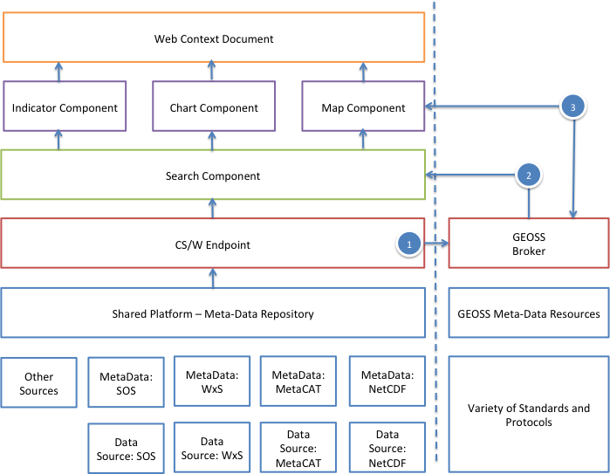

The schematic explains the important standards-based interfaces that will be tested in the pilot:

- Interface between the SAEOS CS/W end point and the GEOSS Broker – exposing South African data contributors to GEOSS through a meta-data service.
- Interface between the SAEOS Search Facility and the GEOSS Broker – allowing SAEOS (and other local portals) to access GEOSS data sets via the broker.
- Interface between the GEOSS Broker and SAEOS mapping, charting, and indicator rendering components: Allowing users of the GEOSS broker to identify and use components (including SAEOS components) that can render, visualize, sub-set, or otherwise exploit the data source.

Timelines

End May 2013: SAEON Preparatory Work Completed
Early June 2013: Agree with ESSI Lab on Integration and Tests
End September 2013: Ready for Test
End October 2013: Tested and Corrected

Description of SAEON

Main implementing organisation: SAEON (South African Environmental Observation Network), a facility of the NRF (National Research Foundation).

SAEON provides data management and preservation infrastructure for its own needs, as well as those of associated projects and initiates – specifically for SAEOS (South African Earth Observation System – a direct contribution to GEOSS), the Risk and Vulnerability Atlas, the BioEnergy Atlas, and several others.

Contact Point: Wim Hugo – Chief Data and Information Officer, SAEON

